Application of Artificial Intelligence

The only good is knowledge and the only evil is ignorance - Socrates

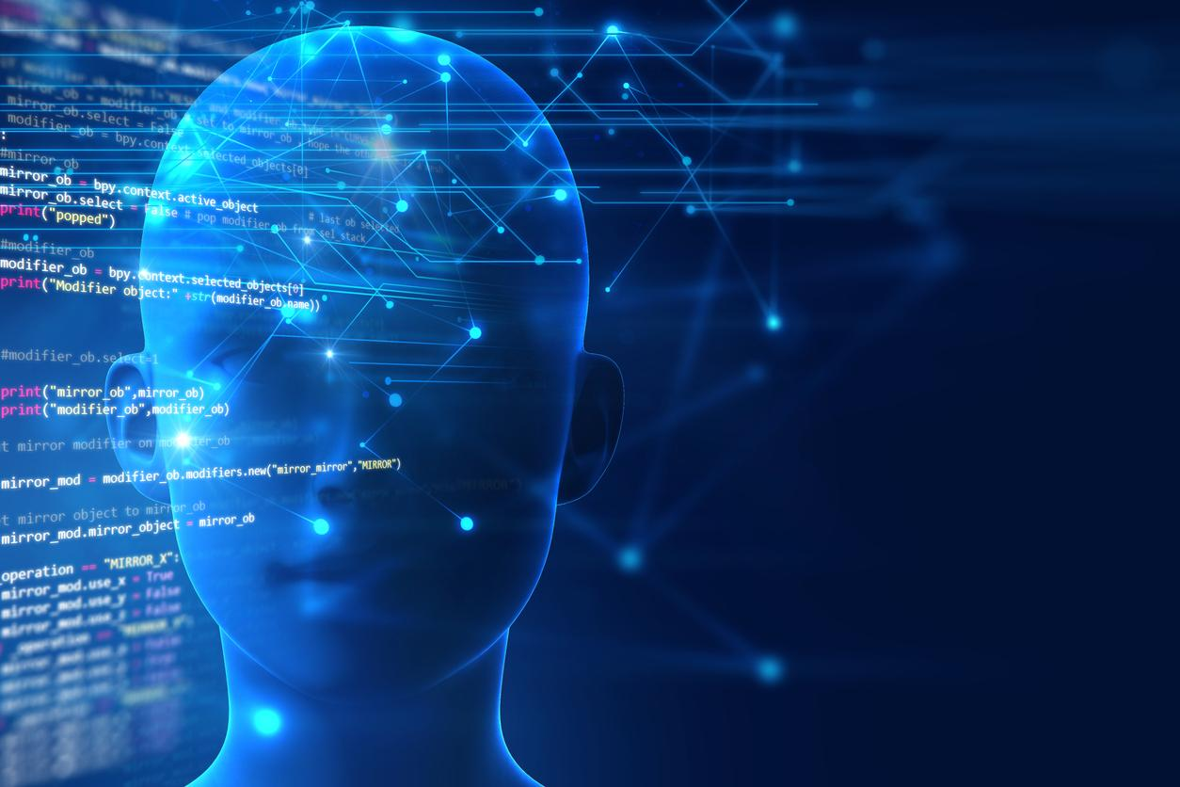

**MUKESH ANAND G**

AI STUDENT AND TECH. ENTHUSIAST

# INTRODUCTION

Artificial Intelligence (AI) is a computer intelligence that mimics human behavior and thinking and may be trained to solve complex problems and make life easier. AI is a combination of Machine Learning and Deep Learning approaches. AI algorithms that have been trained with large amounts of data may make intelligent judgements and increase the efficiency of the work.

# Application of Artificial Intelligence :

#### AI-powered Assistants :

Virtual shopping assistants and chatbots aid in the enhancement of the online buying experience. Natural Language Processing (NLP) is used to make the dialogue sound more human and personal. Furthermore, these assistants can interact with the consumers in real time.

#### Fraud Prevention :

Two of the most serious difficulties that E-Commerce businesses face are credit card fraud and fraudulent reviews. By taking into account usage trends, AI can help to lower the risk of credit card fraud. Many buyers choose to acquire a product or service based on what other people have said about it. Artificial intelligence can assist in detecting and dealing with fraudulent reviews.

#### Autonomous Vehicles:

Automobile manufacturers such as Toyota, Audi, Volvo,Mercedes-Benz, and Tesla use machine learning to teach computers to think and evolve like humans when it comes to driving in any environment and avoiding accidents through object recognition.

#### Facial Recognition :

Face recognition algorithms are used by our favorite devices, such as phones, laptops, and PCs, to detect and identify users in order to enable safe access. Apart from personal use, facial recognition is a commonly utilized Artificial Intelligence application across a variety of businesses, including in high-security settings.

1. Healthcare :

Artificial intelligence has a wide range of uses in the healthcare industry. Artificial intelligence (AI) is being utilized in healthcare to create sophisticated machines that can detect diseases and cancer cells. Artificial Intelligence (AI) can assist in the analysis of chronic illnesses using lab and other medical data in order to ensure early identification. For the discovery of new medications, AI combines a combination of historical data and medical knowledge.

1. Agriculture:

In order to detect flaws and nutrient deficits in the soil, Artificial Intelligence is applied. AI can analyze where weeds are growing utilizing computer vision, robotics, and machine learning techniques. Artificial intelligence bots can assist in the harvesting of crops at a bigger volume and faster rate than human labor.

1. Gaming :

The gaming industry is another area where Artificial Intelligence applications have gained traction. To interact with the players, AI can be employed to generate intelligent, human-like NPCs.

It can also be used to predict human behavior, which can help with game design and testing. AI stalks the player throughout the Alien Isolation games, which were launched in 2014. The game employs two Artificial Intelligence systems: the 'Director AI,' which is constantly aware of your whereabouts, and the 'Alien AI,' which is guided by sensors and behaviors and is always on the lookout for the player.

# Focus on Artificial Brain :

An artificial brain (or artificial mind) is software and technology that mimics the cognitive capacities of a human or animal brain. The sophisticated and unique human brain is posing a challenge to scientists who are keen to understand its complexity and unleash opportunities to improve people's lives. Watson, Siri, and other artificial intelligence (AI)-based systems have already made advancements in human-machine interactions. Artificial neural networks, on the other hand, need to be further reinforced by human natural intelligence if AI is to have a really transformative influence.

# CONCLUSION

With its applications, Artificial Intelligence is transforming industries and assisting in the resolution of complicated problems. Finally, we've seen AI applications in a variety of fields. A lot of industries are on the verge of being transformed by artificial intelligence. Though this is by no means an exhaustive list, it does represent the most likely scenarios in the near future. Predictive analytics and artificial intelligence will undoubtedly play a larger role in content creation and software development in the future. There are opportunities all across the world thanks to open-source information and artificial intelligence. Global technical parity and artificial intelligence technology have the potential to become the future in all areas of health, the environment, public safety, and security.